**Majestic Tech Solutions:**



**Team Members And responsibilities:**

Anthony Granston: Worked on gaming and Home Page,created header.

Jumor Junor: Worked on Laptop for coding,Laptop for gaming.

Dontae Bryan:Worked on creating the About us page with the contact us form and footer.

Ashley Allen: Worked on creating the registration form and Login form,Offerings page.

(All members collaborated and gave it their all in the completion of the project)

**Overview and Purpose**

The website is designed to cater to a diverse audience, offering comprehensive reviews and detailed information about computers tailored to specific needs. Whether you're a gaming enthusiast, a student, or a coder, the site aims to guide you towards the most beneficial options.

For gaming enthusiasts, the website highlights computers with powerful graphics cards, high refresh rates, and ample RAM to handle the latest games smoothly. Reviews delve into performance metrics experience to help users make informed decisions.

Students can benefit from laptops, Designed to meet the diverse needs of modern learners, these laptops offer portability, performance, and reliability to support your educational journey

lightweight designs for portability, and sufficient processing power to handle multitasking. The site showcases laptops ideal for research, note-taking, and multimedia projects, ensuring students can find the best tools for their academic pursuits.

For coders, the website features computers with strong processors, ample RAM for running multiple development tools simultaneously, Detailed reviews cover IDE compatibility, programming language support, and overall efficiency for coding tasks.

In addition to catering to specific needs, the website simplifies the shopping process by organizing computers into categories based on performance, budget, and usage scenarios. This makes it easier for visitors to navigate and find the perfect match based on their requirements.

The primary target audience includes individuals seeking to upgrade their current computer to something better, faster, and more convenient. Whether you're looking for enhanced gaming capabilities, improved productivity, or smoother coding experiences, the website aims to be a valuable resource for anyone in search of their next computer upgrade.

Our website is overall easy on the eyes and it comes with different animations.

**Features And Functionality**

**A) User registration and Login:**

The website provides users with a registration registration form and a log in form upon entering the website,the user is also provided with a login option to ensure that they won't feel the need to create multiple accounts.

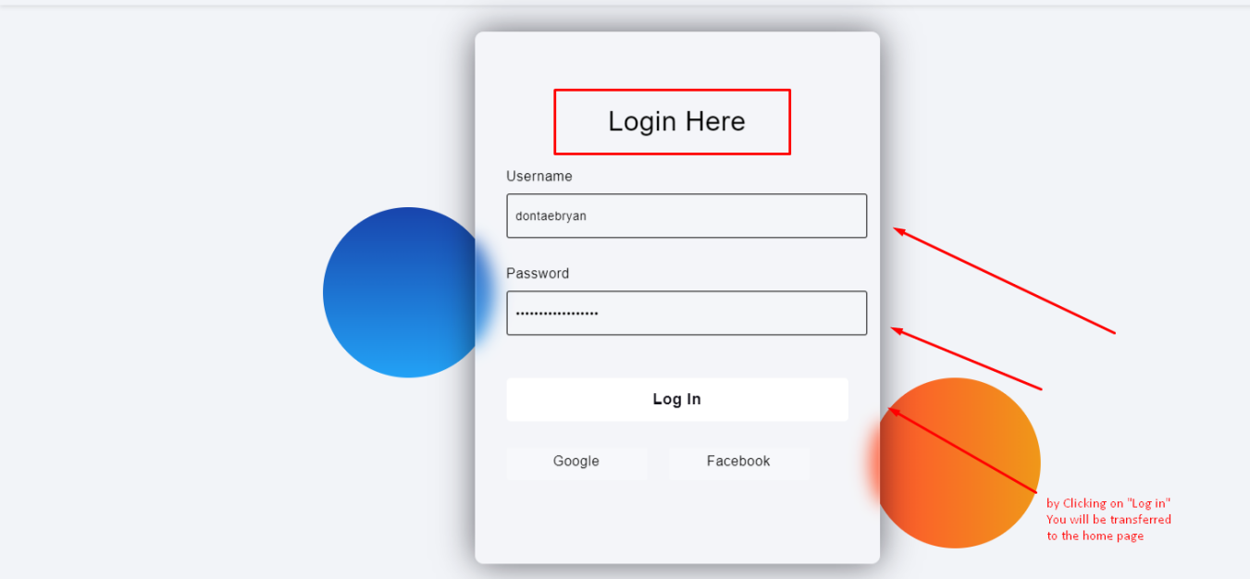

Purpose: Allows new users to create accounts And Login on the website.

Functionality: Users fill out a registration form with their email, password, and other required information. The system validates the data.

Dependencies: Relies on backend user management system and possibly third-party email service for verification.

1. **ii)** **Does user registration depend on an external authentication service?**

User Registration Form: The registration process is handled internally, with users filling out a registration form directly on the website.

Login Page: The login process is handled internally as well, as users are provided with a login option on the website.

**B) Messaging or communication features:**

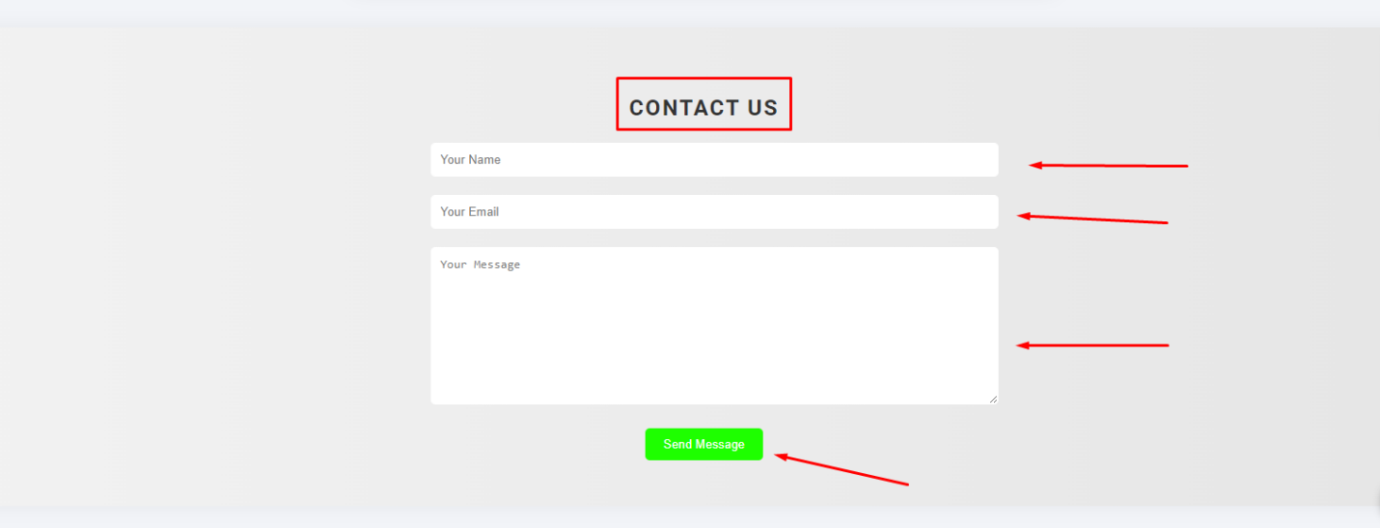

When visitors land on our **(About Us)** page and start scrolling down, they will discover a helpful feature: our **(Contact Us Form)**. This interactive form serves as a direct line of communication between us and our visitors, enabling them to reach out with any information, questions, or inquiries they might have.

The **(Contact Us Form)** is designed to be user-friendly and accessible, encouraging visitors to engage with us effortlessly. Whether they are seeking more information about our services, have specific questions about our products, or wish to explore potential collaborations, this form provides a convenient platform for initiating dialogue.

Upon submitting their messages through the form, our dedicated team promptly receives these inquiries. We prioritize responding to each query promptly and professionally, ensuring that every visitor feels valued and supported. Our goal is to assist them thoroughly and work collaboratively to address their needs and find tailored solutions.

By integrating this **(Contact Us Form)** into our **(About Us page)**, we emphasize our commitment to transparency, accessibility, and customer satisfaction. It's more than just a communication tool—it's a gateway to building meaningful connections and fostering positive relationships with our audience.

We look forward to receiving messages through our **(Contact Us Form)** and engaging with our visitors to provide them with the best possible experience and solutions.

Upon clicking send message a message will appear telling the user if they need to fill out the fields or if it is sent.

**C) Integration with social media platforms:**

When users click on categories such as "Laptops for Gaming," "Laptops for Students," or "Laptops for Coding," they are directed to a curated selection of computers tailored to their specific needs. What sets this experience apart is the integration of informative YouTube reviews by one of the most trusted tech reviewers,

1. Just Josh,
2. Matthew Moniz
3. UrAvgConsumer
4. Jarrod'sTech

Each laptop within these categories is accompanied by a direct YouTube link leading to a detailed review hosted by Just Josh. These video reviews offer comprehensive insights into each computer's features, performance, and suitability for its intended use.

For instance, if a user explores the "Laptops for Coding" section and clicks on a particular model, they will be seamlessly redirected to Just Josh's in-depth review of that laptop on YouTube. Here, they can watch and learn about the laptop's capabilities, including its graphics performance, display quality, cooling system, and overall gaming experience.

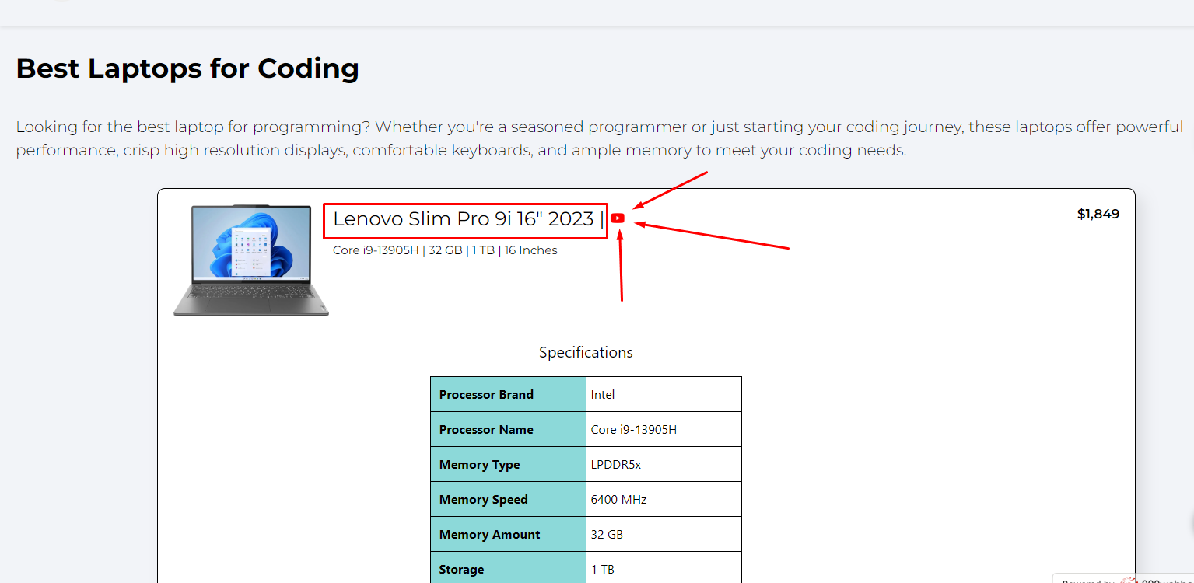

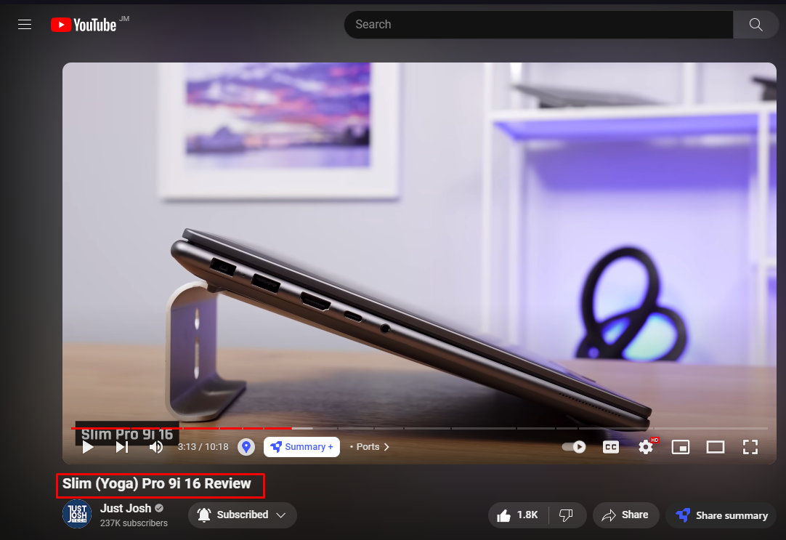

Similarly, for those interested in laptops for students or coding enthusiasts, clicking on a specific model will lead them to Just Josh's review focusing on aspects relevant to students' needs or coding requirements. This could include factors like portability, battery life, software compatibility, and multitasking capabilities.

By leveraging Just Josh's expertise through these YouTube links, users gain valuable firsthand knowledge about each laptop before making an informed decision. This approach not only educates users but also enhances transparency and trust by providing unbiased insights from a respected industry expert.

This integration of curated laptop categories with corresponding YouTube reviews adds significant value to the platform.

**D) Footer:**

In the footer, you'll find convenient navigation options to help users move swiftly around the site. With links to Home, About, Log In, and Blog, users can effortlessly navigate between pages with just a click. Also by clicking on the email you will be taken to gmail where you also email us.

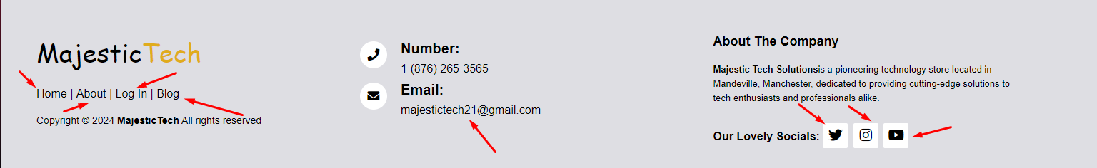

Additionally, we've included three creative icons with animations icons linked to our social media platforms YouTube, Twitter, and Instagram. Clicking on any of these icons will seamlessly redirect users to our official social media pages, allowing them to connect with us and stay updated with our latest news and content.

**Feature: Interactive Homepage**

Purpose: Engage visitors immediately with interactive elements.

Functionality: The homepage features immediate and easy to understand options in order to navigate through the website . Users can click on different sections to learn more.

Dependencies:Html and utilizing CSS for styling.

**Feature: Contact Form**

Purpose: Enable visitors to get in touch with the team.

Functionality: A contact form allows users to send messages directly to us. Includes fields for name, email, and message.

Dependencies: Utilizes backend server for form submission and may integrate with email services for message delivery.

**Feature: Navigation Menu**

Purpose: Facilitate easy navigation throughout the website.

Functionality: A navigation menu provides clear pathways to different sections (e.g., Home, About Us, Login, Contact,Gallery,Offerings).

Dependencies: implemented using HTML/CSS

**User Scenarios or Use Cases:**

Imagine this scenario: a gaming enthusiast visits our website and discovers a computer that piques their interest. They want to delve deeper and watch an in-depth video review about the recommended computer. This is where our handy YouTube-linked feature comes into play. By simply clicking on the YouTube icon beside the computer, they are instantly directed to a comprehensive review video on YouTube, where they can access detailed information.

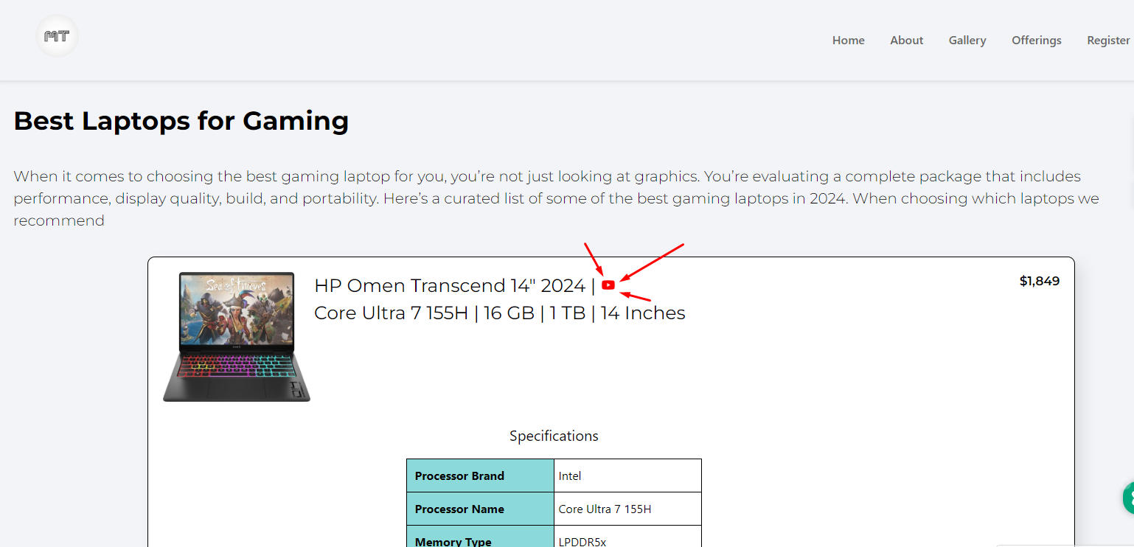

This seamless integration allows users to access expert insights and thorough evaluations of our recommended computers. Whether they're interested in gaming performance, design features, or overall functionality, they can gain a deeper understanding by watching these informative videos.

The goal with that was to provide users the knowledge they need to make informed decisions. With the YouTube-linked feature, they can easily access in-depth information and make confident choices about the computers that best suit their needs and preferences.

**Design and Layout:**

**Layout**:

The website follow a **clean and minimalistic layout**. The content is well-organized, with clear sections for different topics.

The navigation menu is typically located at the top, allowing users to access different pages easily.

The homepage features a **hero section** with a prominent call-to-action (CTA) button, inviting visitors to explore further.

The use of **white space** ensures readability and prevents clutter.

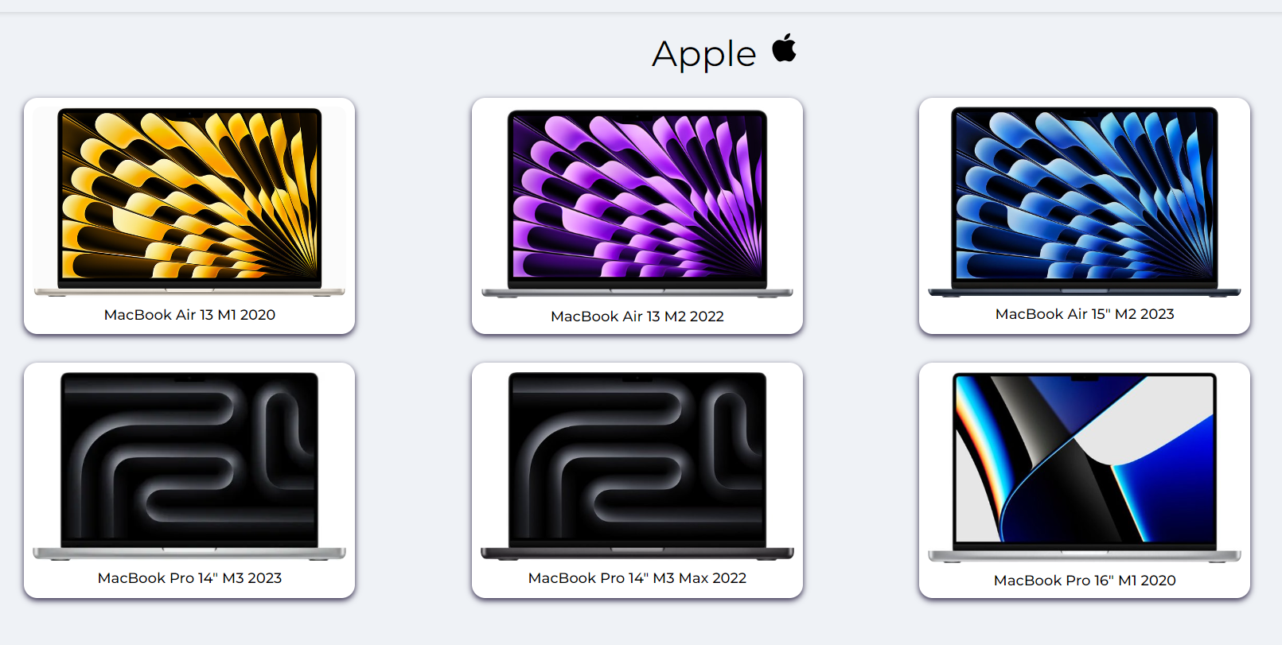

**Color Schemes**:

The color palette seems to be **subdued and professional**. I observed shades of blue, gray, and white.

Blue often conveys trust, reliability, and technology-related themes. It’s a common choice for tech companies.

The consistent use of colors across the site maintains visual harmony.

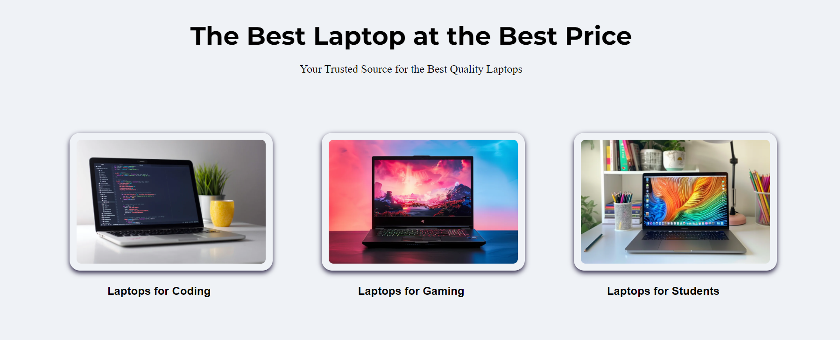

**Typography**:

The website employs **legible fonts** for both headings and body text.

Common font choices for tech websites include sans-serif fonts like **Roboto**, **Open Sans**, or **Lato**.

The font size is appropriate, ensuring readability on various devices.

**Responsive Design**:

The website is **responsive**, adapting well to different screen sizes (desktop, tablet, and mobile).

Elements rearrange gracefully, and the content remains accessible on smaller screens.